**FRONT END USER INTERFACE:**

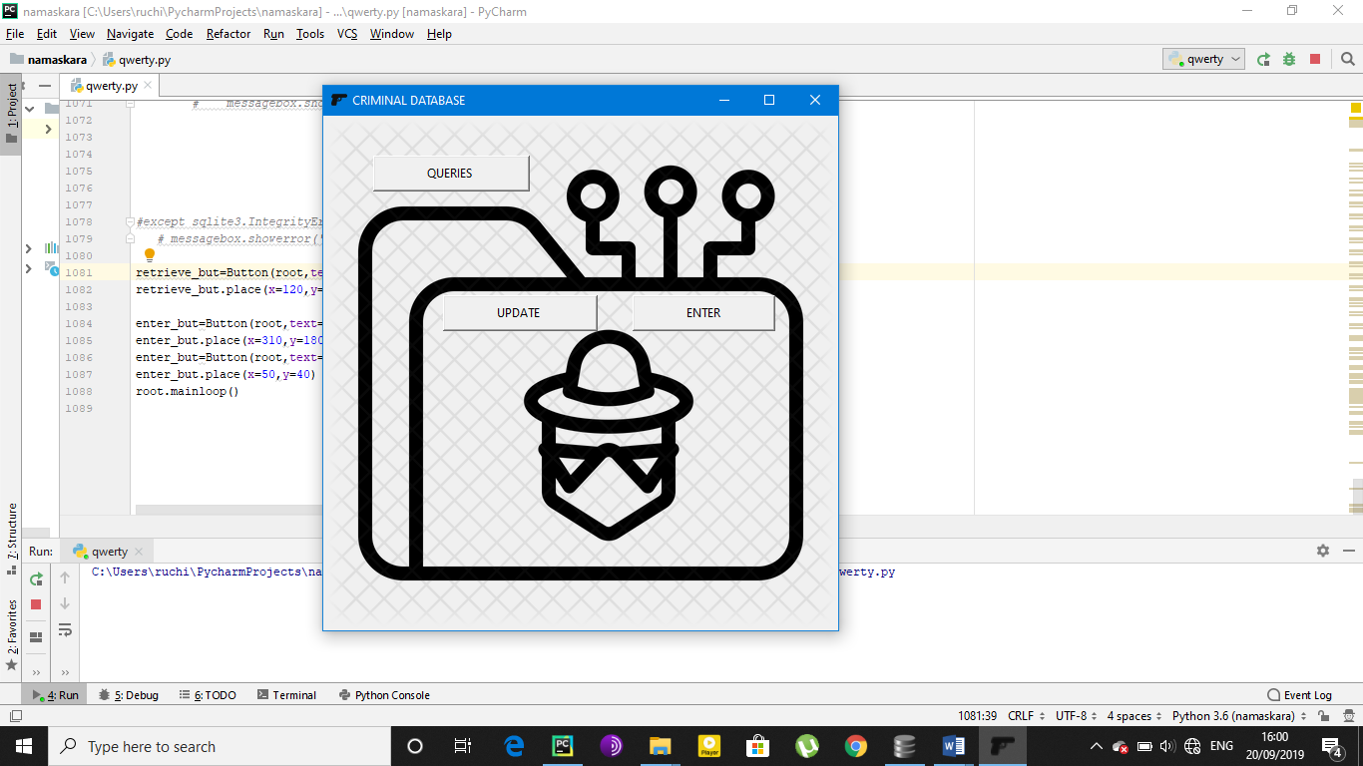

**DATA ENTRY PAGE:**

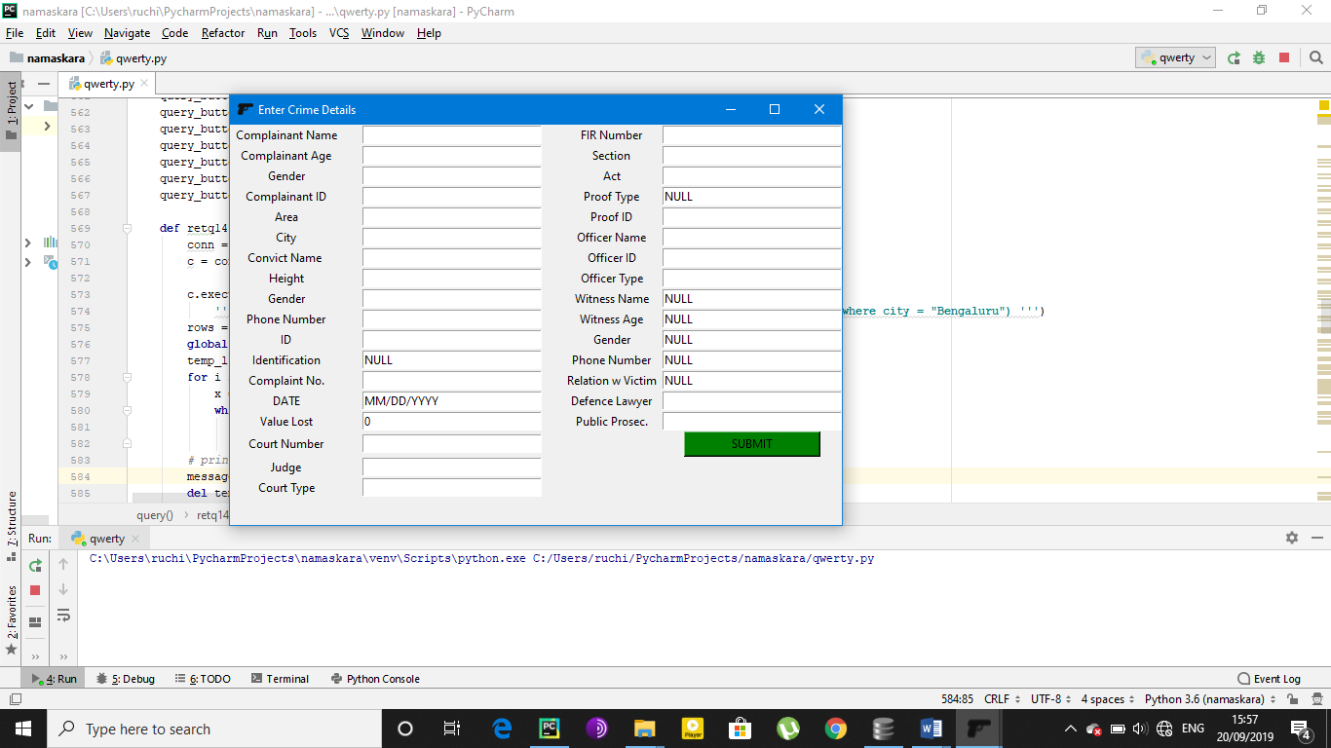

**QUERIES:**

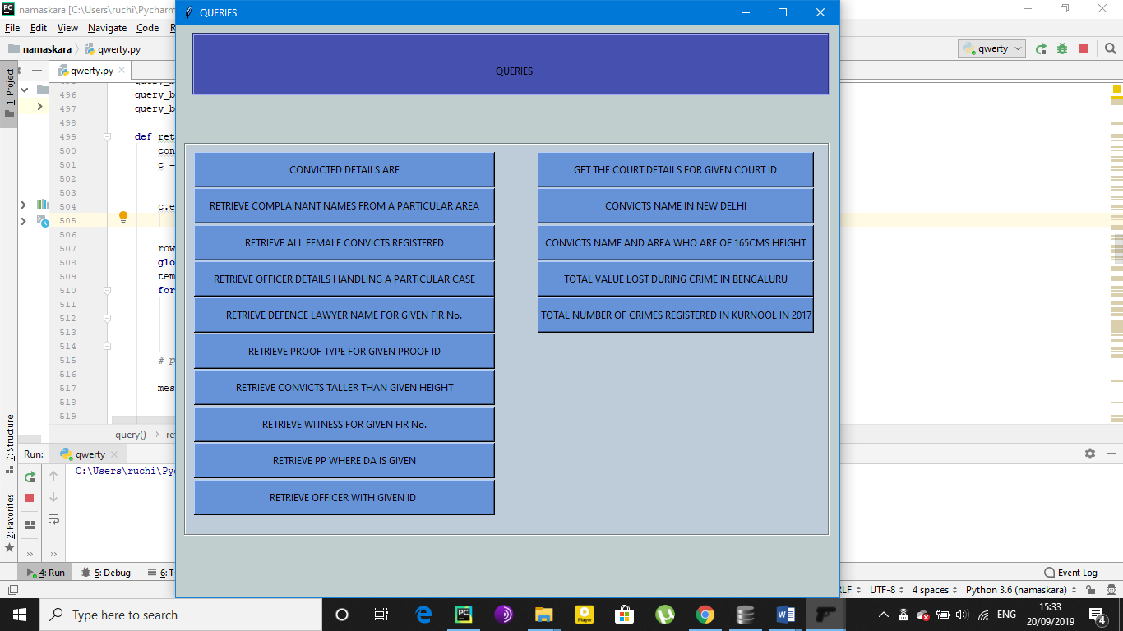

**Q1**->RETRIEVE CONVICTED DETAILS FROM GIVEN FIR No.

Select * from convict where firno = "18-19/288"

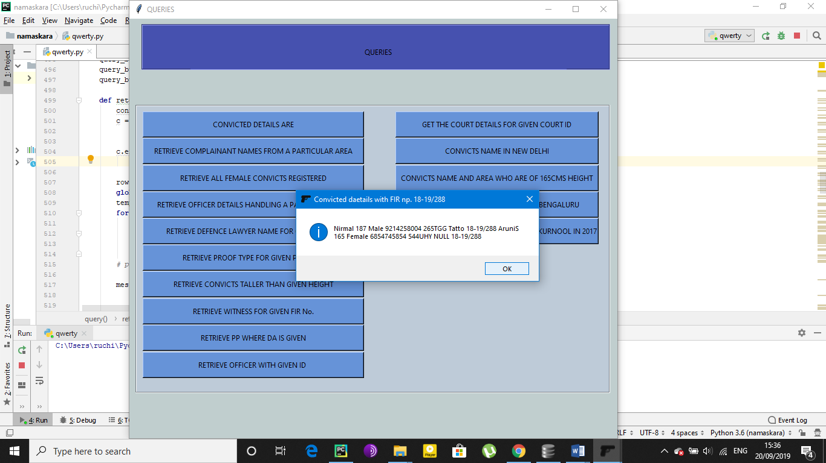

**Q2**->RETRIEVE COMPLAINANT NAMES FROM A PARTICULAR AREA

Select cname from complainant where area = "Vijaynagar"

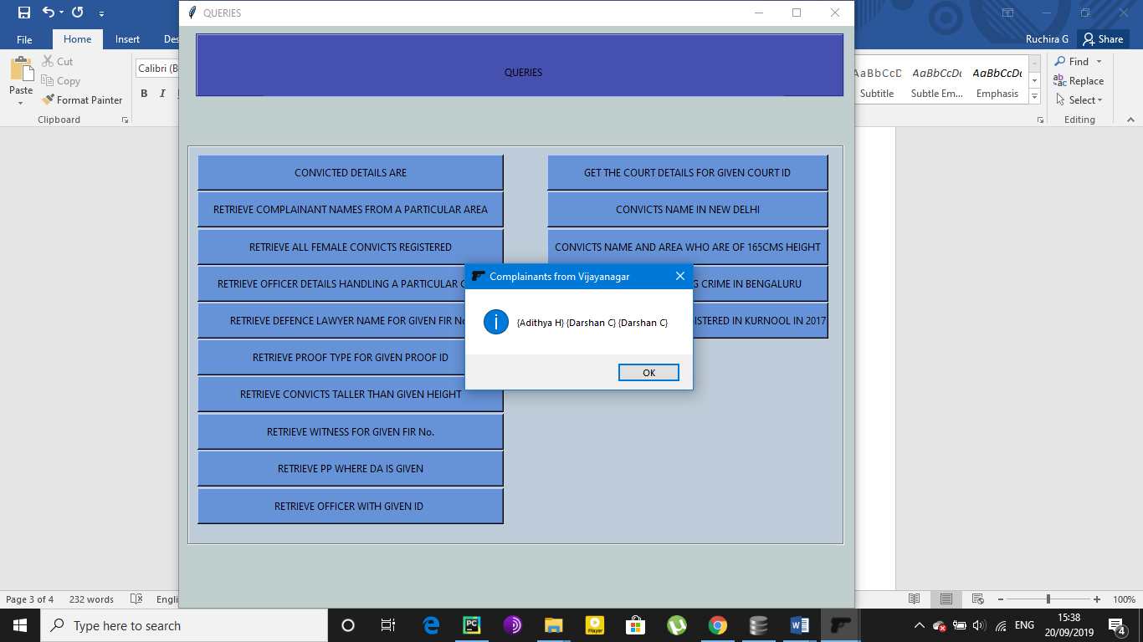

**Q3**->RETRIEVE ALL FEMALE CONVICTS REGISTERED

Select coname from convict where cogen = "Female”

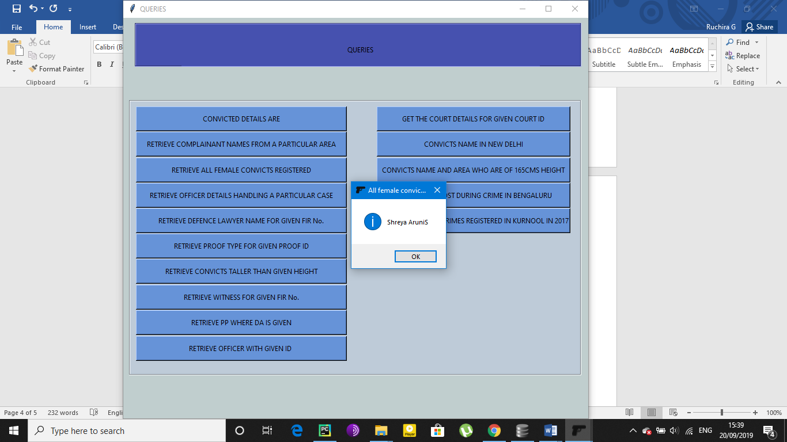

**Q4**->RETRIEVE OFFICER DETAILS HANDLING A PARTICULAR CASE

Select * from officer where firno = "18-19/788"

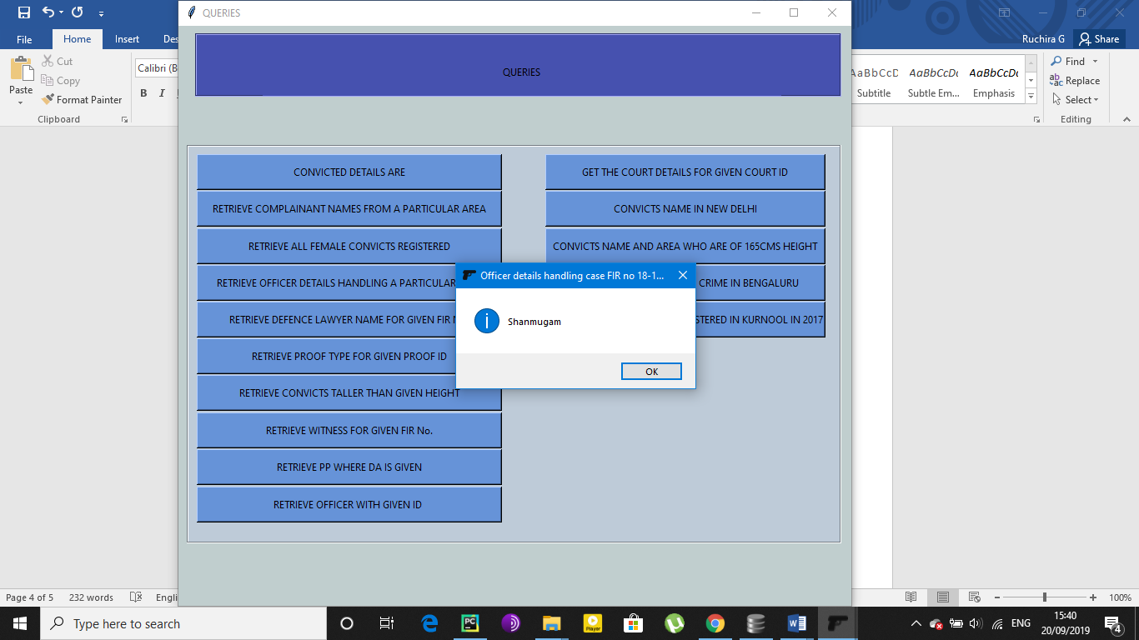

**Q5**->RETRIEVE DEFENSE LAWYER FOR GIVEN FIR No.

Select coutda from court where firno = "18-19/288"

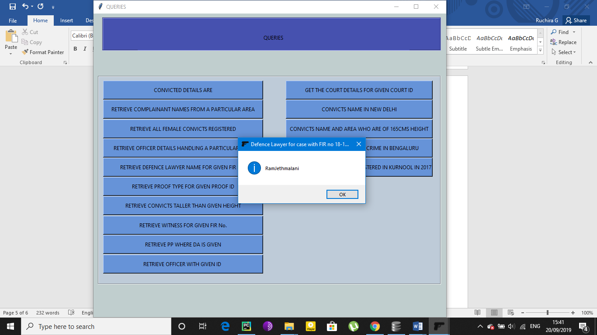

**Q6**->RETRIEVE PROOF TYPE FOR GIVEN PROOF ID

Select prooftype from complaint where proofid = "VT222"

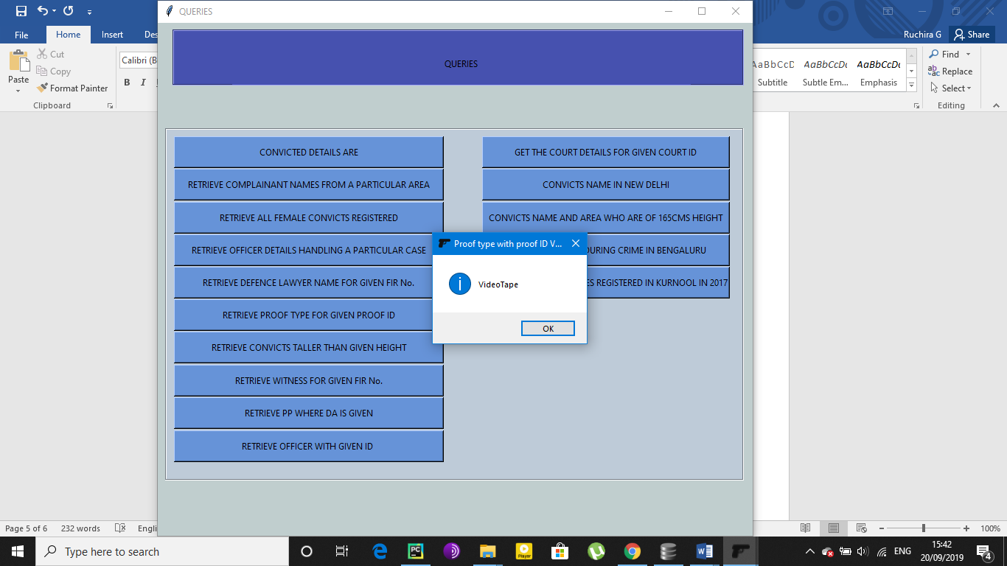

**Q7**->RETRIEVE PP WHERE DA IS GIVEN

Select courtpp from court where courtda = "**CSP**"

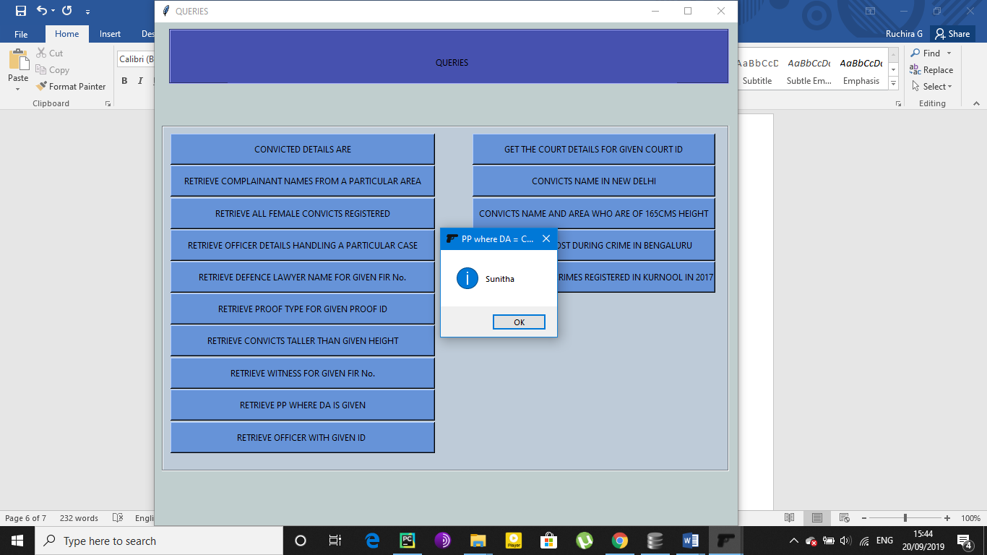

**Q8**->RETRIEVE CONVICTS TALLER THAN GIVEN HEIGHT

Select coname from convict where coheight > 160

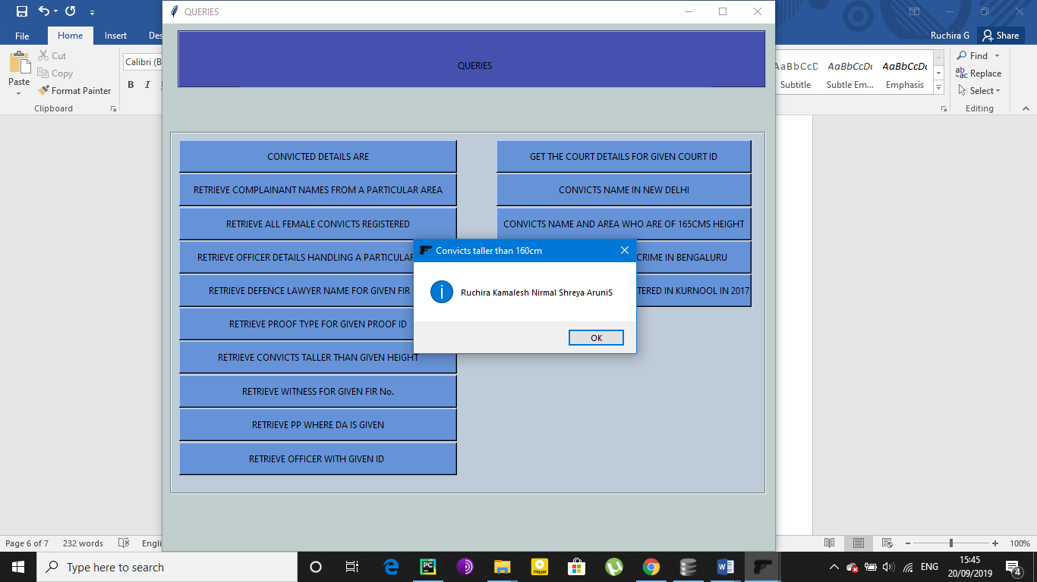

**Q9**->RETRIEVE WITNESS FOR GIVEN FIR No.

Select witname from complaint where firno = "18-19/788"

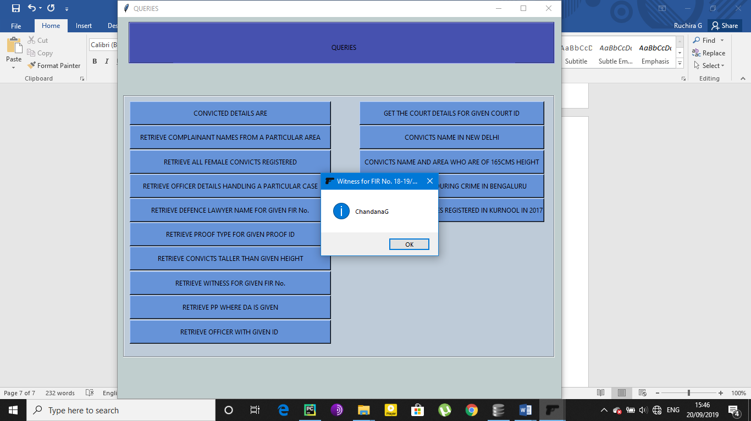

**Q10**->RETRIEVE OFFICER WITH GIVEN ID

Select offname from officer where offid = "KA7891"

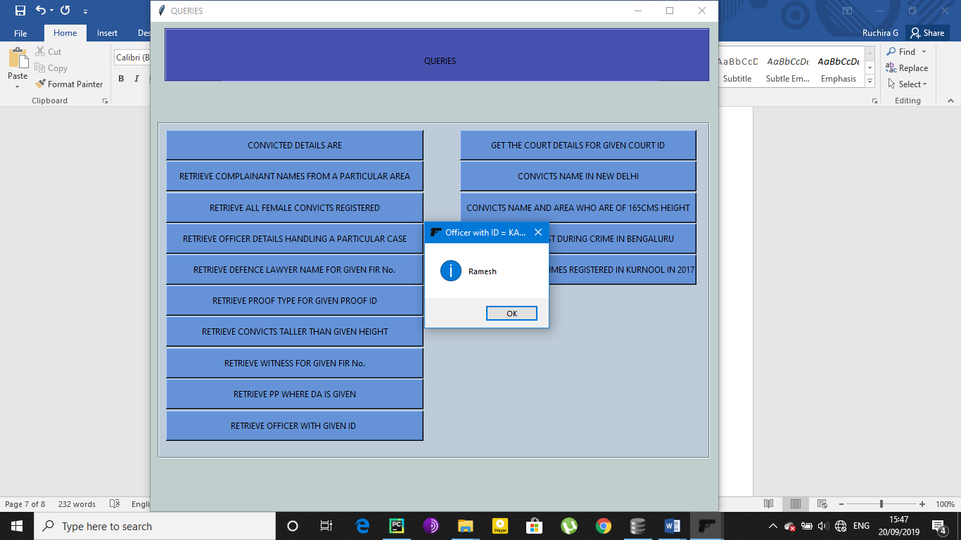

**Q11**->GET THE COURT DETAILS FOR GIVEN COURT ID

Select courttype from court where courtno = "KA341"

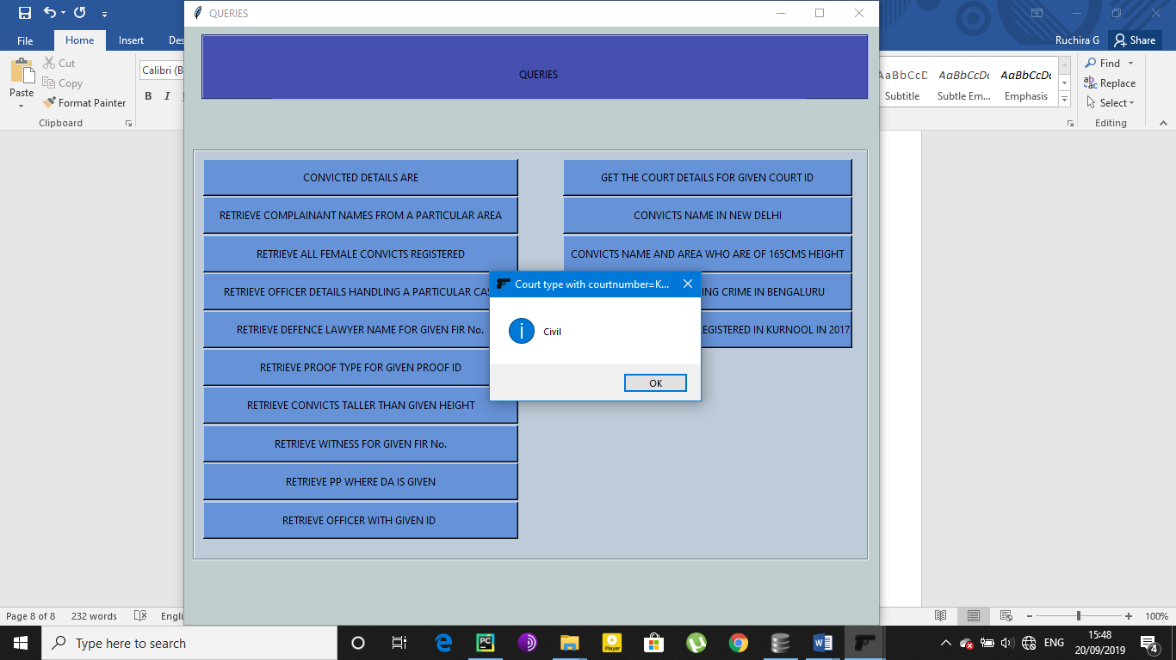

**Q12**->CONVICTS NAME IN NEW DELHI

Select coname from convict where firno = (select firno from complainant where city = "NewDelhi")

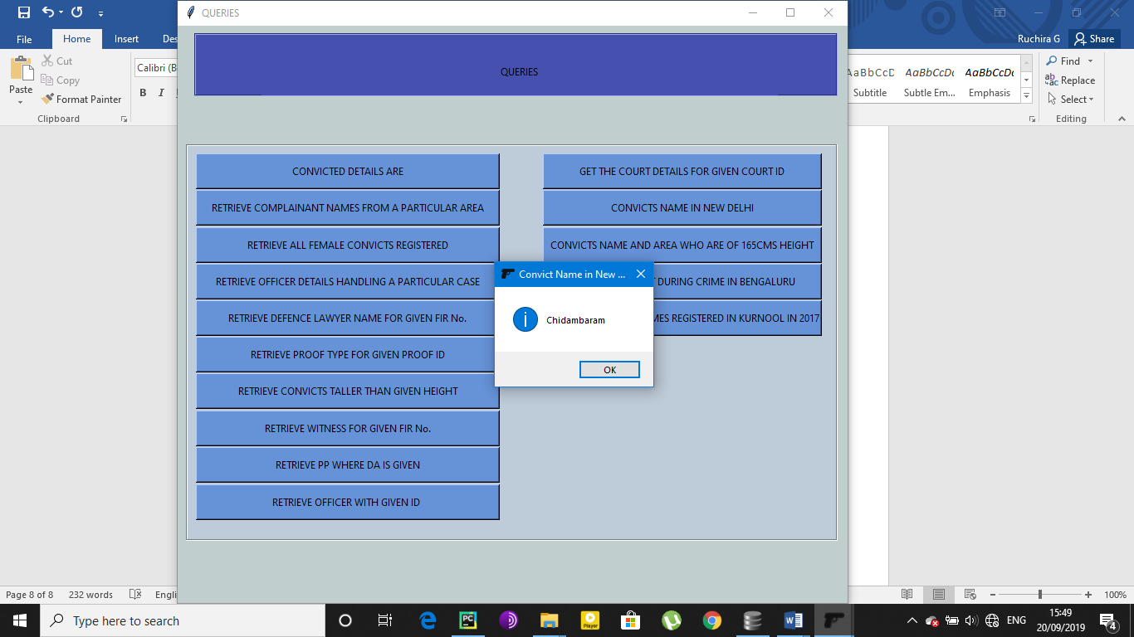

**Q13**->CONVICTS NAME AND AREA WHO ARE OF 165CMS HEIGHT

Select coname from convict where coheight= "165"

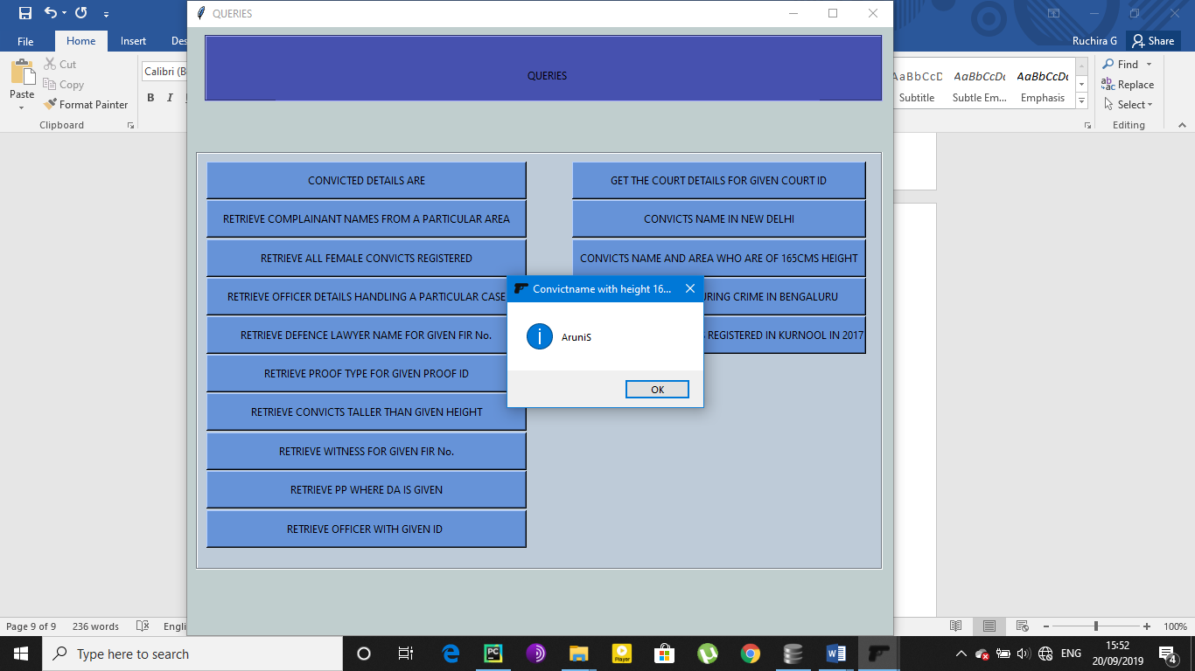

**Q14**->TOTAL VALUE LOST DURING CRIME IN BENGALURU

Select sum(comval) from complaint where complaint.firno = (select firno from complainant where city = "Bengaluru")

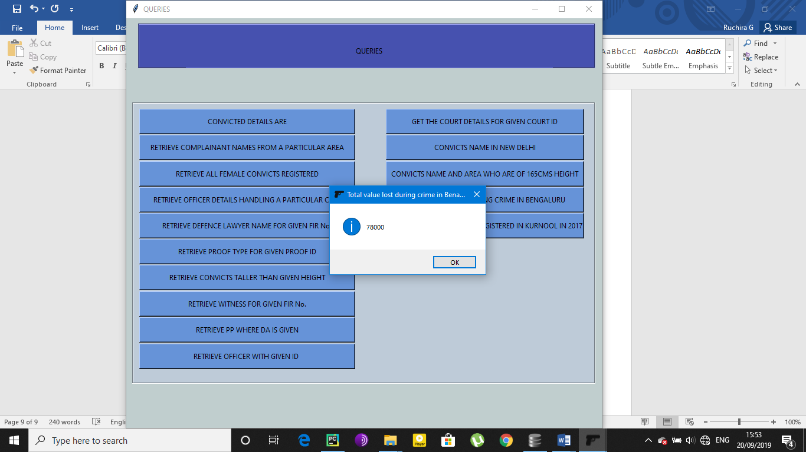

**Q15**->TOTAL NUMBER OF CRIMES REGISTERED IN KURNOOL IN 2017

Select COUNT(*) from complainant where city= "Kurnool and complaint.date=2017%"

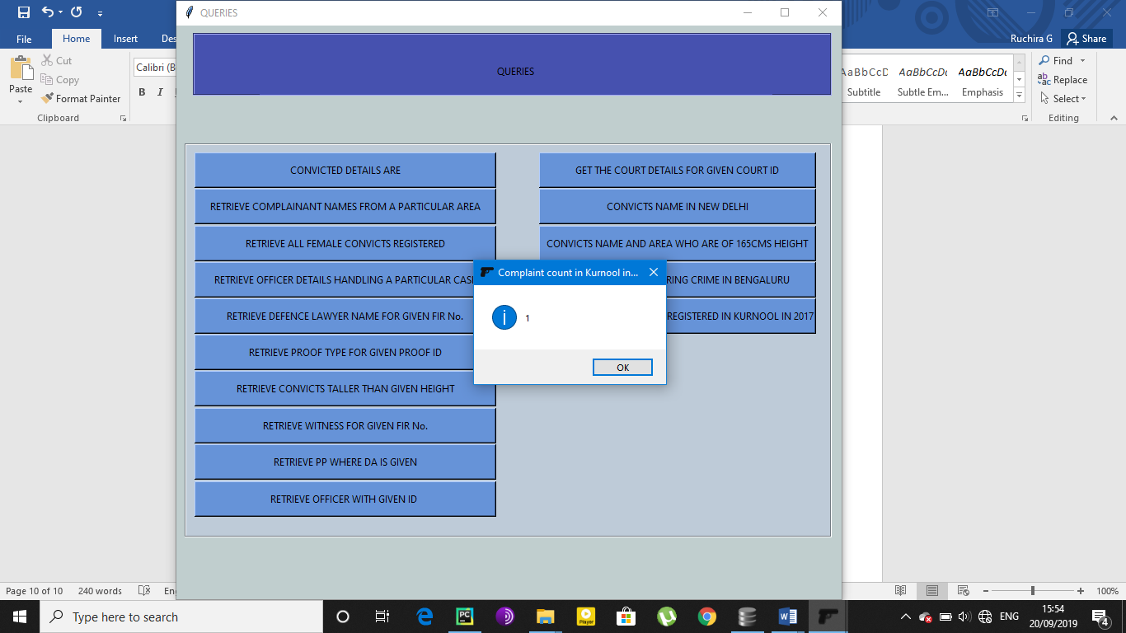

UPDATING THE DATABASE:

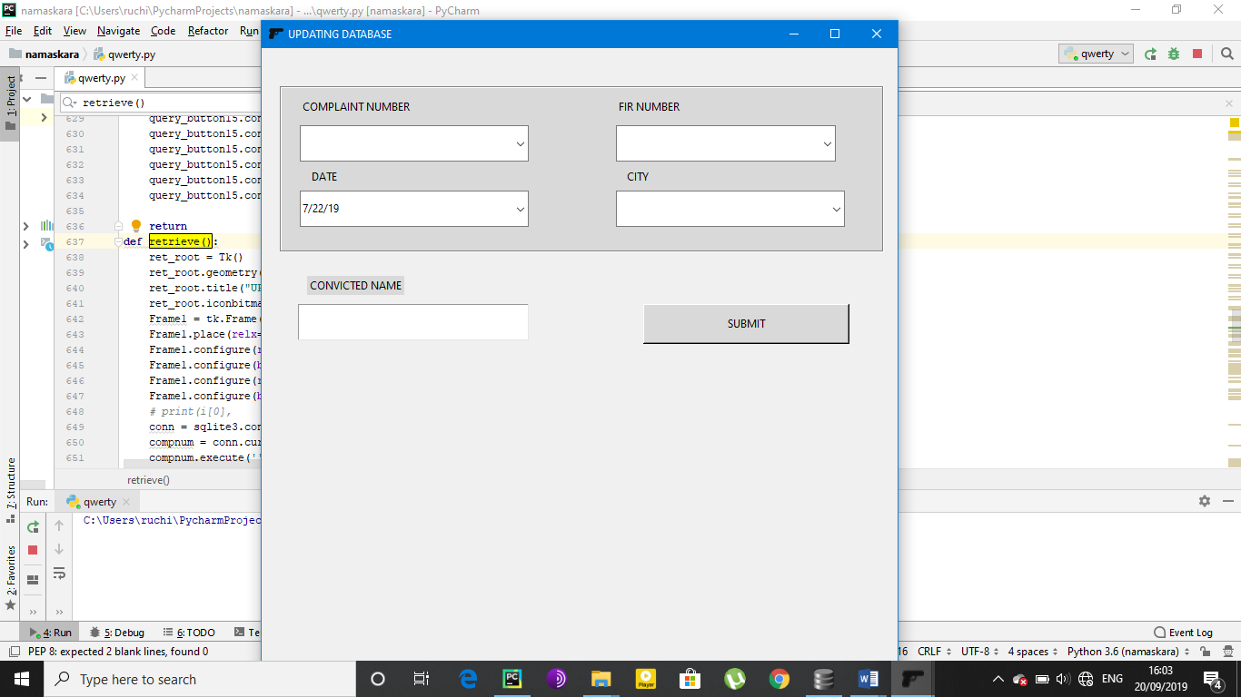

The Database can be updated by entering any one of the above values correctly.

**TRIGGERS:**

In this particular database we have implemented a trigger where it shows an error message when the value column is tried to be changed to zero and sets the column to a Non Available vale N/A for no more further confusion.

**SQL SYNTAX:** CREATE TRIGGER valuenotnull BEFORE INSERT ON COMPLAINT FOR EACH ROW BEGIN IF (NEW. Value IS NULL) THEN INSERT INTO COMPLAINT SET Value = 'N/A'; END IF; end;

